Task 3 — Data Logger (Sensor + SD Card)
Objective
The objective of this task is to collect sensor data and store it in a CSV file on an SD card. The system reads light intensity values from a photoresistor (LDR) sensor and logs timestamped entries continuously. This demonstrates how embedded systems can store real-world sensor data for monitoring and analysis.
Component Used
- Arduino UNO
- Photoresistor (LDR)
- Resistor (10kΩ)
- Micro SD Card Module
- Jumper wires
- Wokwi Simulator
Working Principle
The photoresistor (LDR) is a light-sensitive component whose resistance changes depending on light intensity. The LDR is connected with a resistor to form a voltage divider circuit. The Arduino reads the analog voltage from pin A0 and converts it into a digital value representing light intensity. The SD card module communicates with Arduino using SPI communication protocol. Each sensor reading is stored in CSV format along with a timestamp generated using the millis() function. CSV format is commonly used for data logging because it can be easily opened in Excel or other data analysis software.
Applications
- IoT data logging systems
- environmental monitoring
- smart agriculture
- weather monitoring systems
- industrial sensor logging
Circuit Diagram
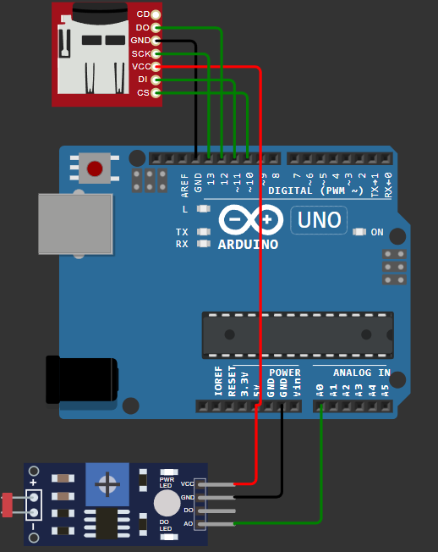
Code
#include <SPI.h>
#include <SD.h>
const int chipSelect = 10;
void setup() {
Serial.begin(9600);
if (!SD.begin(chipSelect)) {
Serial.println("SD card initialization failed");
while(true);
}
Serial.println("SD card initialized");
}
void loop() {
int lightValue = analogRead(A0);
unsigned long timeStamp = millis();
Serial.print(timeStamp);
Serial.print(",");
Serial.println(lightValue);
delay(500);
}
Output ( CSV File Format )
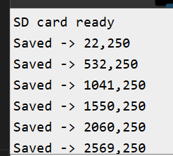
Observation
The sensor value changes depending on the light intensity. When light intensity increases, the analog value increases. When light intensity decreases, the analog value decreases. The serial monitor displays continuous sensor readings which confirms proper working of the system.
Result
The Arduino successfully collected sensor data and stored readings in CSV format. The system recorded more than 100 samples continuously. This demonstrates correct implementation of sensor data logging using SPI communication with SD card module.

